



IAM IS

Highways England

Partial Inspections of Linear Assets Functional Design

**Version 1.4**

Document Version History

|  |  |  |  |
| --- | --- | --- | --- |
| Version | Update Source | Date | Description |
| 0.1 | Paul Stanton | 25-Sep-2014 | Initial Draft |
| 1.0 | Paul Stanton | 15-Oct-14 | Final Version for HA Review |
| 1.1 | Paul Stanton | 11-Dec-2014 | Changes to INSL attribution and additional loader processing rules to support |
| 1.2 | Paul Stanton | 17-Dec-2014 | INSL table correction |
| 1.3 | Paul Stanton | 06-Jan-2015 | Spelling corrections |
| 1.4 | Jim Luff | 06-Nov-2015 | Re-titled with minor amendments |
|  |  |  |  |
| For review | | | For approval |
| Colin Stewart  Chris Spong  James Jaggers  Adrian Hull | | | Colin Stewart  Adrian Hull |

Document last saved on 09-Nov-2015 8:46 AM

Table of Contents

1 About This Document 4

1.1 Document Purpose 4

1.2 Document Terminology 4

1.2.1 Abbreviations 4

1.3 Related Documents 5

2 Introduction 6

2.1 Background 6

2.2 Issue with currently deployed solution 6

3 Proposed Solution 7

3.1 Workflows 7

3.1.1 Existing Workflow 7

3.1.2 Proposed Workflow 8

3.1.3 Overview of Proposed Configuration 9

3.1.4 Example Data 9

4 Technical Design 12

4.1 Metadata Requirements 12

4.1.1 INSP Asset Type - Inspections 12

4.1.2 INSP_INSPECTED Domain 15

4.1.3 INSL Asset Type – Linear Inspection Record 15

4.2 Inspection Updates in the Field 18

4.2.1 Existing Process 18

4.2.2 Required Process Modifications 18

4.3 Inspections updated using CSV Loader Process 19

4.3.1 Existing loader 19

4.3.2 Loader Modifications 19

4.4 Future changes 20

# 

# About This Document

## Document Purpose

This document is the Functional Design to allow the IAM IS system to record partial inspections of Linear Assets. It describes the understood requirements for the partial linear asset inspections and describes a configuration of the COTS product that best meets those requirements along with any changes required to the Inspection Scheduling functionality.

## Document Terminology

The following abbreviations, terms and concepts are used in the document:

### Abbreviations

|  |  |
| --- | --- |
| Abbreviation | Meaning, Definition |
| COTS | Commercial Off the Shelf Software |
| AMOR | Asset Maintenance and Operational Requirements |
| ASC | Asset Support Contract |
| BoQ | Bill of Quantities |
| GRI | Generic Reporting Interface |
| MAI | Maintenance Manager |
| CSV | Comma Separated Vale (typically a data file in plain text format) |
| INSPECT | Format of file |
| LOV | List of Values |
| RTM | Requirements Tracking Matrix |

## 

## Related Documents

Following is the list of documents that this document refers to or that provide with additional information about this topic.

|  |  |
| --- | --- |
| # | Document, Description, Version |
|  | HA-221037_RP_01v09_Maintenance Inspection Scheduling configuration.doc |
|  |  |

# Introduction

## Background

The proposal for the Highways England IAM IS project included the use of standard Exor Maintenance Manager Functionality to schedule Inspections on the Network. During a series of configuration workshops, that included stakeholders from Bentley, ATOS, the Highways England and the HA Area Managing Contractors, it was identified that the COTS Inspection scheduling capabilities did not meet the Asset Maintenance and Operational Requirements (AMOR) the new Asset Support Contract (ASC) demands.

This lead to the specification, development and release of Inspection Scheduling functionality into the IAM IS system which is documented in **HA-221037_RP_01v09_Maintenance Inspection Scheduling configuration.doc**

A further requirement has been identified for capturing the inspections for linear assets, in particular those which are of significant length.

## Issue with currently deployed solution

It has been identified that whilst carrying out inspections on linear assets, in some circumstances the whole asset cannot be inspected at once. Should this occur there is no way to record this in the IAM IS system. Inspections are currently marked with “Date Inspected” and “Inspected?” Yes or No.

A change from the currently deployed solution is to provide a solution where inspections can be captured over multiple days and this be reflected in the IAM IS system.

# Proposed Solution

## Workflows

Bentley in conjunction with the HA IAM IS project team have investigated ways the change can be met through a combination of configuration and modifications to the existing inspection scheduling solution.

### Existing Workflow

### Proposed Workflow

The changes only impact the inspection component of the workflow, Scheduling of inspections, batching and downloading of inspections will not change and are not in included in this flowchart.

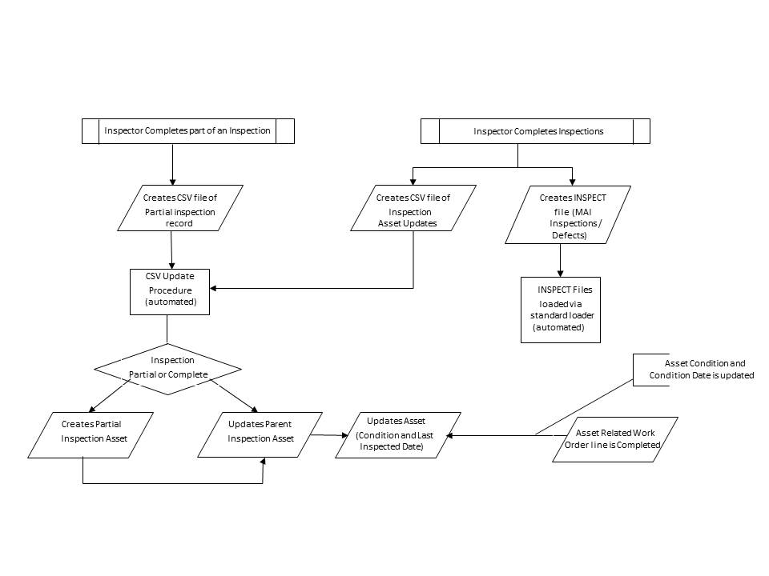

### Overview of Proposed Configuration

It is proposed that these requirements are met by adding a second optional inspection record which will be a child of the Scheduled Asset inspection record (INSP).

Should the scheduled inspection not be fully complete, the partial inspection data will be captured and loaded into IAM IS, the load process will identify which inspection is partial and link this to the parent inspection, updating it to be flagged as partially complete.

The parent inspection can have as many partial inspections as required, with the final partial child inspection being flagged as complete. The load of this final partial child inspection will update the parent inspection status to complete and update the date inspected; this in turn will update the last inspected date of the asset on which the parent inspection was scheduled.

### Example Data

The following screenshots show how an inspection completed over two days will be displayed in the system and each child inspections impact on the parent inspection.

**Figure 1**

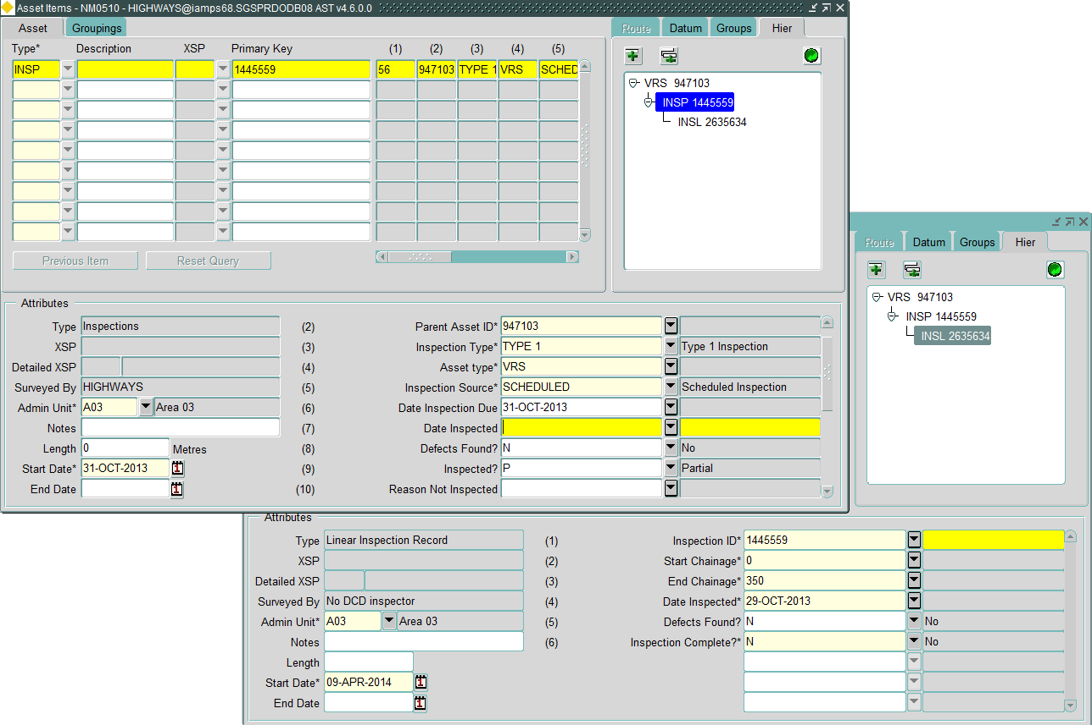

Inspection 1445559 not completed on 29-Oct-2013, child inspection 2635634 records the start and end of the inspection carried out on 29-Oct-2013, and the “Inspection Complete” attribute is marked as No.

On loading into the system the parent inspection is updated to show “Inspected?” attribute as Partial, the “Date Inspected” attribute is not updated.

**Figure 2**

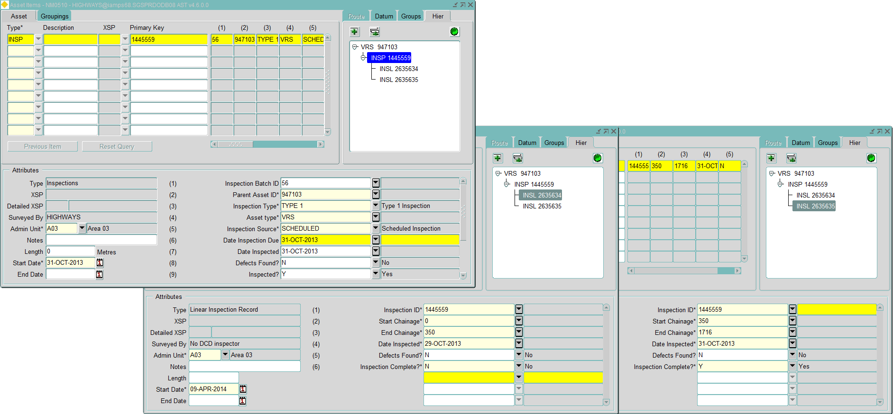

The remaining part of inspection 1445559 completed on 31-Oct-2013, child inspection 2635635 records the start and end of the inspection carried out on 31-Oct-203, and the “Inspection Complete” attribute is marked as Yes.

On load into the system the parent inspection is updated to show “Inspected?” attribute is Yes, the “Date Inspected” attribute is updated. The asset being inspected is updated as before when the parent inspections “Date Inspected” is recorded.

# Technical Design

## Metadata Requirements

The following metadata must be created and or amended to support the proposal.

### INSP Asset Type - Inspections

The INSP asset type attributes will remain largely unchanged.

The exception being the “Inspected?” attribute which will change to be validated against a new asset domain INSP_INSPECTED – See 4.1.4

The table on the next page shows the metadata required for the Inspection asset type, with the changes highlighted in green.

Notes:

1. The Admin Type should be set to the Admin Type of all other Assets, e.g. NETW. Each occurrence of an Inspection Asset will take the Admin Unit from its respective Parent Asset.
2. Appropriate Roles and Mode of access will be defined.
3. An Asset Grouping record must be created for each Parent Asset Type that requires an Inspection Schedule.

|  |  |  |  |  |  |  |  |  |  |  |  |  |  |  |  |  |  |  |  |  |  |  |  |  |  |  |  |  |  |  |  |  |
| --- | --- | --- | --- | --- | --- | --- | --- | --- | --- | --- | --- | --- | --- | --- | --- | --- | --- | --- | --- | --- | --- | --- | --- | --- | --- | --- | --- | --- | --- | --- | --- | --- |
| **Asset Type** | | | **Description** | | | | | | | | | | | | | | | | | | **Point / Continuous** | | | **Category** | | | | **Admin Type** | | | | |
| **INSP** | | | **Inspections** | | | | | | | | | | | | | | | | | | **Point** | | | **I** | | | | **NETW** | | | | |
| **Asset Type Flags** | | | | | | | | | | | | | | | | | | | | | | | | | | | | | | | | |
| **Linear** | | | | | **XSP Allowed** | | | **Contiguous** | | | **Replaceable** | | | | **Exclusive** | | | **USE XY** | | | | **Multiple Allowed** | | | **End Location Only** | | | | | **Top in Hierarchy** | | |
| **⌧** | | | | | **⌧** | | | **⌧** | | | **🗹** | | | | **⌧** | | | **⌧** | | | | **⌧** | | | **⌧** | | | | | **⌧** | | |
| **Attributes** | | | | | | | | | | | | | | | | | | | | | | | | | | | **Flags** | | | | | |
| **Seq** | **Attribute Name** | | | | | **Screen Text** | | | | **Len** | | **Format** | | **Domain** | | | **Case** | | | **View Attribute & Column Name** | | | | | | **Mand** | **Quer** | | **Excl** | | **Insp** | **Disp** |
| **1** | **IIT_NUM_ATTRIB100** | | | | | **Inspection batch ID** | | | | **22** | | **NUMBER** | |  | | | **UPPER** | | | **INSP_BATCH_ID** | | | | | | **⌧** | **🗹** | | **⌧** | | **🗹** | **🗹** |
| **2** | **IIT_FOREIGN_KEY** | | | | | **Parent Asset Id** | | | | **50** | | **VARCHAR2** | |  | | | **UPPER** | | | **INSP_PARENT_ID** | | | | | | **🗹** | **⌧** | | **⌧** | | **⌧** | **⌧** |
| **3** | **IIT_CHR_ATTRIB31** | | | | | **Parent Asset Type** | | | | **50** | | **VARCHAR2** | |  | | | **UPPER** | | | **INSP_PARENT_TYPE** | | | | | | **🗹** | **🗹** | | **⌧** | | **🗹** | **🗹** |
| **4** | **IIT_CHR_ATTRIB26** | | | | | **Inspection Type** | | | | **50** | | **VARCHAR2** | | **INSP_TYPE** | | | **UPPER** | | | **INSP_TYPE** | | | | | | **⌧** | **⌧** | | **⌧** | | **⌧** | **⌧** |
| **5** | **IIT_CHR_ATTRIB29** | | | | | **Inspection Source** | | | | **50** | | **VARCHAR2** | | **INSP_SOURCE** | | | **UPPER** | | | **INSP_SOURCE** | | | | | | **⌧** | **⌧** | | **⌧** | | **⌧** | **⌧** |
| **6** | **IIT_DATE_ATTRIB86** | | | | | **Date Inspection due** | | | | **7** | | **DATE** | |  | | | **UPPER** | | | **INSP_DATE_DUE** | | | | | | **⌧** | **⌧** | | **⌧** | | **⌧** | **⌧** |
| **7** | **IIT_DATE_ATTRIB87** | | | | | **Date Inspected** | | | | **7** | | **DATE** | |  | | | **UPPER** | | | **INSP_DATE_INSPECTED** | | | | | | **⌧** | **⌧** | | **⌧** | | **⌧** | **⌧** |
| **8** | **IIT_CHR_ATTRIB27** | | | | | **Defects Found?** | | | | **3** | | **VARCHAR2** | | **Y/N** | | | **UPPER** | | | **INSP_DEF_FOUND_FLAG** | | | | | | **⌧** | **⌧** | | **⌧** | | **⌧** | **⌧** |
| **9** | **IIT_CHR_ATTRIB28** | | | | | **Inspected?** | | | | **3** | | **VARCHAR2** | | **INSP_INSPECTED** | | | **UPPER** | | | **INSP_INSPECTED_FLAG** | | | | | | **⌧** | **⌧** | | **⌧** | | **⌧** | **⌧** |
| **10** | **IIT_CHR_ATTRIB66** | | | | | **Reason Not Inspected** | | | | **500** | | **VARCHAR2** | |  | | | **Mixed** | | | **INSP_NOT_INSP_REASON** | | | | | | **⌧** | **⌧** | | **⌧** | | **⌧** | **⌧** |
| **11** | **IIT_CHR_ATTRIB30** | | | | | **Condition Rating** | | | | **50** | | **VARCHAR2** | | **INSP_COND** | | | **UPPER** | | | **INSP_CONDITION** | | | | | | **⌧** | **⌧** | | **⌧** | | **⌧** | **⌧** |
| **12** | **IIT_CHR_ATTRIB67** | | | | | **Condition Comment** | | | | **500** | | **VARCHAR2** | |  | | | **Mixed** | | | **INSP_CONDITION_COMMENT** | | | | | | **⌧** | **⌧** | | **⌧** | | **⌧** | **⌧** |
| **Networks** | | | | | | | | | | | | | | | | | | | | | | | | | | | | | | | | |
| **Type** | | **Unique** | | | | | | | **Description** | | | | **Location Mandatory** | | | | | | **Start Date** | | | | | | | | | | | | | |
| **D** | | **DOT** | | | | | | | **DOT SECTION** | | | | **NULL** | | | | | | **01-JAN-2000** | | | | | | | | | | | | | |
| **Roles** | | | | | | | **Groupings** | | | | | | | | | | | | | | | | | | | | | | | | | |
| **Role** | | | | **Mode** | | | **Parent** | | | | | | | | | **Mandatory** | | | | | | | **Relation** | | | | | | | | | |
| **See note 2** | | | |  | | | **See note 3** | | | | | | | | | **🗹** | | | | | | | **NONE** | | | | | | | | | |

### INSP_INSPECTED Domain

Validates the “Inspected?” attribute. It is used to indicate if the Inspection has taken place or not, or is in progress.

|  |  |  |  |  |
| --- | --- | --- | --- | --- |
| **Inventory Domain** | | | | |
| **Domain** | | **Title** | | **Datatype** |
| **INSPECTED?** | | **Inspected?** | | **VARCHAR2** |
| **Domain Values** | | | | |
| **Seq** | **Value** | | **Meaning** | |
| **1** | **Y** | | **Yes** | |
| **2** | **N** | | **No** | |
| **3** | **P** | | **Partial** | |

### INSL Asset Type – Linear Inspection Record

The INSL asset type is a new asset type used to hold information about a partial inspection.

The table on the next page shows the metadata required for the Inspection asset type

|  |  |  |  |  |  |  |  |  |  |  |  |  |  |  |  |  |  |  |  |  |  |  |  |  |  |  |  |  |  |  |  |  |
| --- | --- | --- | --- | --- | --- | --- | --- | --- | --- | --- | --- | --- | --- | --- | --- | --- | --- | --- | --- | --- | --- | --- | --- | --- | --- | --- | --- | --- | --- | --- | --- | --- |
| **Asset Type** | | | **Description** | | | | | | | | | | | | | | | | | | **Point / Continuous** | | | **Category** | | | | **Admin Type** | | | | |
| **INSL** | | | **Linear Inspection Record** | | | | | | | | | | | | | | | | | | **Point** | | | **I** | | | | **NETW** | | | | |
| **Asset Type Flags** | | | | | | | | | | | | | | | | | | | | | | | | | | | | | | | | |
| **Linear** | | | | | **XSP Allowed** | | | **Contiguous** | | | **Replaceable** | | | | **Exclusive** | | | **USE XY** | | | | **Multiple Allowed** | | | **End Location Only** | | | | | **Top in Hierarchy** | | |
| **⌧** | | | | | **⌧** | | | **⌧** | | | **🗹** | | | | **⌧** | | | **⌧** | | | | **⌧** | | | **⌧** | | | | | **⌧** | | |
| **Attributes** | | | | | | | | | | | | | | | | | | | | | | | | | | | **Flags** | | | | | |
| **Seq** | **Attribute Name** | | | | | **Screen Text** | | | | **Len** | | **Format** | | **Domain** | | | **Case** | | | **View Attribute & Column Name** | | | | | | **Mand** | **Quer** | | **Excl** | | **Insp** | **Disp** |
| **1** | **IIT_FOREIGN_KEY** | | | | | **Iisfhjsfjs Scheduled Inspection ID** | | | | **50** | | **VARCHAR2** | |  | | | **UPPER** | | | **INSP_INSPECTION_ID** | | | | | | **🗹** | **🗹** | | **⌧** | | **⌧** | **🗹** |
| **2** | **IIT_NUM_ATTRIB100** | | | | | **Start Chainage** | | | | **22** | | **NUMBER** | |  | | | **UPPER** | | | **START_CHAINAGE** | | | | | | **⌧** | **🗹** | | **⌧** | | **⌧** | **🗹** |
| **3** | **IIT_NUM_ATTRIB101** | | | | | **End Chainage** | | | | **22** | | **NUMBER** | |  | | | **UPPER** | | | **END_CHAINAGE** | | | | | | **⌧** | **🗹** | | **⌧** | | **⌧** | **🗹** |
| **4** | **IIT_DATE_ATTRIB86** | | | | | **Date Inspected** | | | | **7** | | **DATE** | |  | | | **UPPER** | | | **DATE_INSPECTED** | | | | | | **🗹** | **🗹** | | **⌧** | | **⌧** | **🗹** |
| **5** | **IIT_CHR_ATTRIB28** | | | | | **Defects Found?** | | | | **3** | | **VARCHAR2** | | **Y_OR_N** | | | **UPPER** | | | **INSL_DEF_FOUND** | | | | | | **🗹** | **🗹** | | **⌧** | | **⌧** | **🗹** |
| **6** | **IIT_CHR_ATTRIB29** | | | | | **Inspection Complete?** | | | | **3** | | **VARCHAR2** | | **Y_OR_N** | | | **UPPER** | | | **INSL_INSP_COMPLETE** | | | | | | **🗹** | **🗹** | | **⌧** | | **⌧** | **🗹** |
| **7** | **IIT_CHR_ATTRIB30** | | | | | **Condition Rating** | | | | **50** | | **VARCHAR2** | | **INSP_COND** | | |  | | | **INSL_CONDITION** | | | | | | **⌧** | **🗹** | | **⌧** | | **🗹** | **🗹** |
| **8** | **IIT_CHR_ATTRIB67** | | | | | **Condition Comment** | | | | **500** | | **VARCHAR2** | |  | | |  | | | **INSL_CONDITION_COMMENT** | | | | | | **⌧** | **🗹** | | **⌧** | | **🗹** | **🗹** |
| **9** | **IIT_X** | | | | | **Start X (Easting)** | | | | **6** | | **NUMBER** | |  | | |  | | | **START_EASTING** | | | | | | **⌧** | **🗹** | | **⌧** | | **🗹** | **🗹** |
| **10** | **IIT_Y** | | | | | **Start Y (Northing)** | | | | **6** | | **NUMBER** | |  | | |  | | | **START_NORTHING** | | | | | | **⌧** | **🗹** | | **⌧** | | **🗹** | **🗹** |
| **11** | **IIT_X_COORD** | | | | | **End X (Easting)** | | | | **6** | | **NUMBER** | |  | | |  | | | **END_EASTING** | | | | | | **⌧** | **🗹** | | **⌧** | | **🗹** | **🗹** |
| **12** | **IIT_Y_COORD** | | | | | **End Y (Northing)** | | | | **6** | | **NUMBER** | |  | | |  | | | **END_NORTHING** | | | | | | **⌧** | **🗹** | | **⌧** | | **🗹** | **🗹** |
| **Networks** | | | | | | | | | | | | | | | | | | | | | | | | | | | | | | | | |
| **Type** | | **Unique** | | | | | | | **Description** | | | | **Location Mandatory** | | | | | | **Start Date** | | | | | | | | | | | | | |
| **D** | | **DOT** | | | | | | | **DOT SECTION** | | | | **NULL** | | | | | | **01-JAN-2000** | | | | | | | | | | | | | |
| **Roles** | | | | | | | **Groupings** | | | | | | | | | | | | | | | | | | | | | | | | | |
| **Role** | | | | **Mode** | | | **Parent** | | | | | | | | | **Mandatory** | | | | | | | **Relation** | | | | | | | | | |
| **See note 1** | | | |  | | | **INSP** | | | | | | | | | **🗹** | | | | | | | **NONE** | | | | | | | | | |

Notes:

1. Appropriate Roles and Mode of access will be defined.

## Inspection Updates in the Field

### Existing Process

When an Inspector carries out a survey they ‘update’ the appropriate Inspection attributes on the INSP assets. This would include the ‘Date Inspected’, the ‘Defects Found’ Flag’, etc, as well as the ‘Condition’ attributes.

The INSP asset updates are exported in the form of a CSV file, which is transferred to an FTP site. From there the files are processed into the system by a scheduled process.

### Required Process Modifications

Should an inspector not be able to compete a scheduled inspection in one day, they will now have the option to create an INSL – Linear inspection asset as a child asset of the INSP asset.

If an INSL asset is created the following attributes are required:

* Scheduled Inspection ID - needs to be populated with the ID of the parent INSP asset.
* Date Inspected
* Defects Found? - The INSL “defects found?” attribute will update the parent INSP “Defects Found?” attribute.
* Inspection Complete
* One or both of the following combinations will need to be supplied for the starting location:

Start X (Easting) & Start Y (Northing) or Start Chainage

* One or both of the following combinations will need to be supplied for the ending location:

End X (Easting) & End Y (Northing) or End Chainage

Attributes “Condition Rating” and “Condition Comment” will be optional

At the end of an inspection the modified records will be exported to CSV.

The INSP asset and any INSL assets will need to be exported in a CSV file format.

## Inspections updated using CSV Loader Process

### Existing loader

Once the CSV files containing the INSP asset updates are uploaded to the FTP site, the files are picked up by a scheduled process and the INSP assets are updated in IAM IS.

If the INSP asset attribute ‘Date Inspected” is populated the asset on which the inspection has taken place has its last inspected date for the inspection type updated.

### Loader Modifications

With the possibility of both an INSP and INSL csv the update process will need to cater for this.

Both the INSP and INSL csv files will be placed on the FTP site in the same folder and picked up by a scheduled process.

The files will be processed in the following asset order:

1. INSL
2. INSP

The INSL assets will be created as children of the parent INSP asset, the supplied “Scheduled Inspection ID” will be used to link the INSL to the correct INSP.

If an INSL has been created and the “Inspection Complete?” attribute is N, then the “Inspected?” attribute of the parent INSP will be updated to P for Partial.

If “Inspection Complete?” attribute is Y then then “Inspected?” attribute of the parent INSP will be updated to Y for Yes. The “Date Inspected” attribute of the parent INSP will also be updated with the same value of the INSL “Date Inspected” attribute. Since the INSP asset attribute ‘Date Inspected” is populated, the asset on which the inspection has taken place will have its last inspected date for the inspection type updated.

The INSL “Defects found?” attribute will update the parent INSP “Defects Found?” attribute, this is mandatory for an INSL asset, once a INSL asset has been created the update of INSP will not update the INSP “Defects found?” attribute. Additional INSL assets will only update the INSP “Defects Found?” if it has not already been updated to “Y”.

The INSP asset updates will then be processed.

Should an INSL asset need to be created, then the closure of the INSP by updating the “Date Inspected” and “Inspected?” attributes, will occur with the final INSL asset with the “Inspection Complete?” set to Y.

If an INSL asset is created the only attributes that can be updated via the INSP update will be:

* Reason not Inspected
* Condition Rating
* Condition Comment

The two condition related attributes will represent the overall condition of the asset.

## Future changes

For those using MapCapture:

When MapCapture fully supports hierarchical assets, the creation of the INSL will be much improved since the software will populate the “Scheduled Inspection ID”.

At this point the MapCapture users will no longer be required to export the INSP and INSL as CSV files and the updates will occur as part of the standard asset creation and updates process used by “regular assets” created and edited in MapCapture.